**Deploy ELEMENTS for HPC on a virtual machine**

This article describes the steps for running the CFD software [ELEMENTS](https://engys.com/products/elements) on a Virtual Machine (VM) and a HPC cluster that have been deployed on Azure Cloud Platform. It also presents the performance results of ELEMENTS on Azure while running on single-node and multi-node VM configurations. ELEMENTS version 3.5.0 was employed to complete all tests.

**About ELEMENTS**

ELEMENTS is a groundbreaking CFD and optimization software solution for vehicle design applications produced by Streamline Solutions LLC, a joint venture between [ENGYS](https://engys.com) and [Auto Research Center](http://www.arcindy.com/). The simulation engine delivered with this tool is powered by [HELYX](https://engys.com/products/helyx) to offer a cost-effective solution that combines the best of automotive engineering design practices with the latest and most advanced open-source CFD and optimization methods developed by ENGYS, all within a unified, easy-to-use platform.

ELEMENTS has been developed to help automotive engineers and designers complete the following tasks:

* **Evaluate vehicle designs more efficiently** using a completely new ribbon-based GUI layout focused on functional design.
* **Automate external vehicle aerodynamics calculations** using a virtual wind tunnel wizard with fully configurable best simulation practices, automatic report creation, added support for rotating tyres/wheels, and new ride height and frontal area calculators.
* **Solve more complex engineering problems** with improved CFD methods and tools for UHMT, HVAC, in-cabin flows and aeroacoustics, including better volume meshing, faster and more stable solvers, added support for multi-region CHT, etc.
* **Leverage on-demand computing and cloud services** with a dedicated client-server framework for working remotely via secure network connections.
* **Improved usability and productivity** through powerful open-source CFD solvers and utilities developed and maintained by ENGYS.

**Azure Architecture**

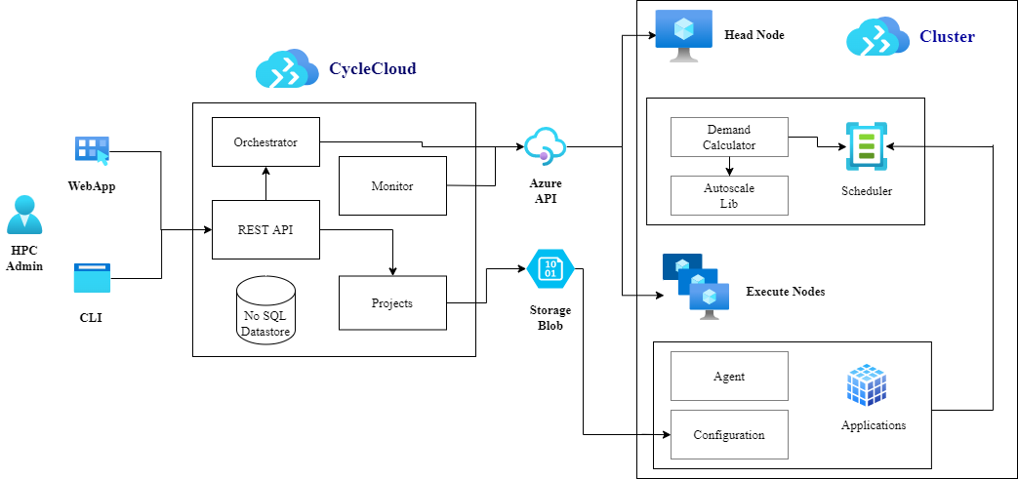

**Components**

* [Azure Virtual Machines](https://azure.microsoft.com/services/virtual-machines). Create Linux and Windows virtual machines in seconds.
* [Azure Virtual Network](https://azure.microsoft.com/services/virtual-network). Use Virtual Network to create your own private network infrastructure in the cloud.

**Install ELEMENTS 3.5.0 on a VM and HPC Cluster**

The software ELEMENTS must be purchased from ENGYS or one of their local authorized distributors/agents to get the installation files and technical support with the application. Contact [ENGYS](https://engys.com/products/helyx) if you are interested in buying ELEMENTS.

Before you install ELEMENTS, you need to deploy and connect a VM or HPC Cluster.

For information about deploying the VM and installing the drivers, see one of these articles:

* [Run a Windows VM on Azure](https://docs.microsoft.com/en-us/azure/architecture/reference-architectures/n-tier/windows-vm)
* [Run a Linux VM on Azure](https://docs.microsoft.com/en-us/azure/architecture/reference-architectures/n-tier/linux-vm)

For information about deploying the Azure CycleCloud and HPC cluster, see below articles:

* [Install and configure Azure CycleCloud](https://docs.microsoft.com/en-us/learn/modules/azure-cyclecloud-high-performance-computing/4-exercise-install-configure/)
* [Create a HPC Cluster](https://docs.microsoft.com/en-us/learn/modules/azure-cyclecloud-high-performance-computing/5-exercise-create-cluster/)

**Test Models**

Two vehicle models were considered for testing the parallel scalability performance of ELEMENTS version 3.5.0 on Azure, namely:

* [DrivAer](https://www.epc.ed.tum.de/en/aer/research-groups/automotive/drivaer/) sedan model (mid-size computational grid) external vehicle aerodynamics.
* Generic Truck Utility ([GTU](https://www.ecara.org/driveaer/gtu)) model (large computational grid) external vehicle aerodynamics.

All the computational grids were created in parallel as part of the execution process using the hex-dominant meshing utility provided with ELEMENTS.

The details of each test model are shown below: 

**Model 1 – Automotive\_DESdrivAer**

|  |  |  |
| --- | --- | --- |
| **image showing model 1 -Automotive_DESdrivAer** | **Model Details** | |
| **Mesh Size** | 17,000,000 cells |
| **Solver** | DES (helyxAero) |
| **Transient** | 400 time steps |

**Model 2 – Automotive\_GTU-0001**

|  |  |  |
| --- | --- | --- |
| image showing model 2 -Automotive_GTU-0001 | **Model Details** | |
| **Mesh Size** | 116,000,000 cells |
| **Solver** | DES (helyxAero) |
| **Transient** | 3583  time steps |

**ELEMENTS 3.5.0 Performance Results on Single-Node VM**

The performance results achieved running ELEMENTS in parallel on single-node Azure [HBv3 AMD EPYC™ 7V73X](https://docs.microsoft.com/en-us/azure/virtual-machines/hbv3-series) (Milan-X) VMs are presented below as baseline for comparing with multi-node runs. Only Model 1 was considered for single-node tests.

**Model 1 - Automotive\_DESdrivAer**

| **Number of**  **cores** | **Total Solver time  in seconds** | **Relative Solver**  **Speedup** |
| --- | --- | --- |
| 16 | 3102.28 | 1.00 |
| 32 | 1938.16 | 1.60 |
| 64 | 1395.36 | 2.22 |
| 96 | 1337.25 | 2.32 |
| 120 | 1318.55 | 2.35 |

**Single-Node Tests Observations**

For all single-node tests we have taken the solver time on HB120-16rs\_v3 (16 cores) as the reference to calculate the relative speed up with respect to other similar VMs with more cores. The results for Model 1 presented above show that parallel performance in ELEMENTS improves as we increase from 16 to 64 cores, then above 64 cores no further scalability is attained. This is a common occurrence with CFD solvers and other memory intensive applications due to the saturation of the onboard memory available on each processor.

The AMD EPYC™ 7V73​-series (Milan-X) featured in the Azure HBv3 VMs tested here is a very capable processor with 768MB of total L3 cache. Our single-node tests confirm that this memory is sufficient to guarantee parallel scalability of the ELEMENTS solvers when using half the cores available on each 7V73​-series chip.

**ELEMENTS 3.5.0 Performance Results on Multi-Node (Cluster)**

The single-node tests carried out with ELEMENTS confirmed that the solver exhibits proper parallel performance when using up to 64 cores with HBv3 VMs. Therefore, we employed only 64 cores to evaluate the performance of ELEMENTS with [Standard\_HB120-64rs\_v3](https://learn.microsoft.com/en-us/azure/virtual-machines/hbv3-series) when testing multi-node (cluster) configurations. The results are shared below for each test case considered in this study:

**Model 1 - Automotive\_DESdrivAer**

| **Number of Nodes** | **Number of cores** | **Cells per Core** | **Total Solver time**  **in seconds** | **Relative Solver Speedup** |
| --- | --- | --- | --- | --- |
| 1 | 64 | 265625 | 1370.81 | 1.00 |
| 2 | 128 | 132813 | 630.86 | 2.17 |
| 4 | 256 | 66406 | 351.83 | 3.90 |
| 8 | 512 | 33203 | 206.36 | 6.64 |
| 16 | 1024 | 16602 | 168.07 | 8.16 |

**Model 2 - Automotive\_GTU-0001**

| **Number of Nodes** | **Number of cores** | **Cells per Core** | **Total Solver time**  **in seconds** | **Relative Solver Speedup** |
| --- | --- | --- | --- | --- |
| 1 | 64 | 1812500 | 102740.23 | 1.00 |
| 2 | 128 | 906250 | 47761.85 | 2.15 |
| 4 | 256 | 453125 | 21484.47 | 4.78 |
| 8 | 512 | 226563 | 9595.72 | 10.71 |
| 16 | 1024 | 113281 | 5125.38 | 20.05 |

**Multi-Node Tests Observations**

The multi-node performance tests for Model 1 (mid-size mesh) show that the parallel scalability of ELEMENTS in this particular case is appropriate, albeit below optimal. This suboptimal performance can be explained by the relatively low number of cells per core employed when running with 8 and 16 nodes. Solver performance is known to be reduced due to excessive data communication between processor boundaries when the number of cells count per core is low.

By contrast, the results for Model 2 (large mesh) confirm that solver scalability is outstanding and above optimal. The number of cells per core in this case never drops below 100,000, even when using 16 nodes. This is encouraging because most real-life CFD external vehicle aerodynamic models feature 100 million cells or more.

**Pricing**

Only solver time has been considered for the cost calculations. Meshing times, installation time and software costs have been ignored.

You can use the [Azure pricing calculator](https://azure.microsoft.com/pricing/calculator) to estimate VM costs for your configurations.

The following tables provide the solver times in hours. The Azure VM hourly rates are subject to change. To compute the cost, multiply the solver time by the number of nodes and the Azure VM hourly cost which you can find [here for Windows](https://azure.microsoft.com/pricing/details/virtual-machines/windows/#pricing)  and [here for Linux](https://azure.microsoft.com/pricing/details/virtual-machines/linux/#pricing).

**Model 1 - Automotive\_DESdrivAer**

|  |  |
| --- | --- |
| **Number of Nodes** | **Solver time (Hr)** |
| 1 | 0.458 |
| 2 | 0.256 |
| 4 | 0.168 |
| 8 | 0.148 |
| 16 | 0.162 |

**Model 2 - Automotive\_GTU-0001**

|  |  |
| --- | --- |
| **Number of Nodes** | **Solver time (Hr)** |
| 1 | 28.888 |
| 2 | 13.622 |
| 4 | 6.249 |
| 8 | 2.990 |
| 16 | 1.761 |

**Conclusions**

* ELEMENTS 3.5.0 was successfully tested on Azure using HBv3 standalone Virtual Machines and Azure Cycle Cloud multi-node (cluster) configurations.
* All external vehicle aerodynamics models tested demonstrated good CPU acceleration when running in multi-node configurations.
* The meshing, setup and solver applications in ELEMENTS can all be run in parallel, thus making this CFD tool ideal for execution in multi-node configurations (no need for mesh decomposition/reconstruction).
* The simulation engine delivered with ELEMENTS is open source, which means users can run as many simulations in as many processors as needed without incurring additional license costs. This is particularly useful when performing DES-type external aerodynamic calculations.
* For better parallel performance when running DES-type calculations with ELEMENTS we recommend using 64 cores per HBv3 node and a minimum of 50,000 cells per core.

**Contributors**

*This article is maintained by Microsoft. It was originally written by the following contributors.*

Principal authors:

* [Hari Bagudu](https://www.linkedin.com/in/hari-bagudu-88732a19) | Senior Manager
* [Gauhar Junnarkar](https://www.linkedin.com/in/gauharjunnarkar) | Principal Program Manager
* [Preetham Y M](https://www.linkedin.com/in/preetham-y-m-6343a6212/) | HPC Performance Engineer

Other contributors:

* [Mick Alberts](https://www.linkedin.com/in/mick-alberts-a24a1414) | Technical Writer
* [Guy Bursell](https://www.linkedin.com/in/guybursell) | Director Business Strategy
* [Sachin Rastogi](https://www.linkedin.com/in/sachin-rastogi-907a3b5) | Manager

*To see non-public LinkedIn profiles, sign into LinkedIn.*